

|  |
| --- |
| Zero Feature Release |
| A program assisting healthily getting fat |



|  |  |  |  |  |
| --- | --- | --- | --- | --- |
| **제출일** | 2018. 5. 20. |  | **전공** | 컴퓨터공학부 |
| **과목** | 소프트웨어공학 |  | **학번** | 20141405 |
| **담당교수** | 송인식 |  | **이름** | 최형준 |

***Contents***

1. Documentation for Users

* A description of your project – p3
* How a user obtains and install the software (including prerequisites)
* How to run the software
* A high-level description of the user view of your software
* How to use the software
* How to report a bug

1. Documentation for developers

* How to obtain the source code
* The layout of your directory structure
* How to build the software
* How to test the software
* How to set up an automated daily (or more frequent) build and test
* How to release a new version of your software
* How to access the list of outstanding bugs and the list of resolved bugs, and how to resolve a bug

1. **Documentation for Users**
   * A description of your project

* Product Introduction

“Fatter” application is a **program** that **assists low weight people healthily getting fats**. **Low weight people** have a greater chance to **suffer from diseases** such as pneumothorax than others.

On the internet or in app markets, **all fitness programs focus on losing weights**. Through providing useful information to get fat, this program will **uniquely help low weight people**.

* Project Details

|  |  |
| --- | --- |
| **Number of team members / Development Method** | 6 people / pair programming |
| **Software Tools** | 1. Java Swing – for making GUI  2. Jsoup – for crawling  3. Eclipse – for compiling java codes |
| **Design Model** | MVC model |
| **Programming Language** | Java |
| **Testing Method** | 1. Unit Test by JUnit  2. Class Test by testing *main function* in each class |
| **Debugging Method** | Debugging by eclipse debugger |

* + How a user obtains and install the software (including prerequisites)
* Prerequisite
* Java Download
  1. Download Java from <https://java.com/ko/download/>.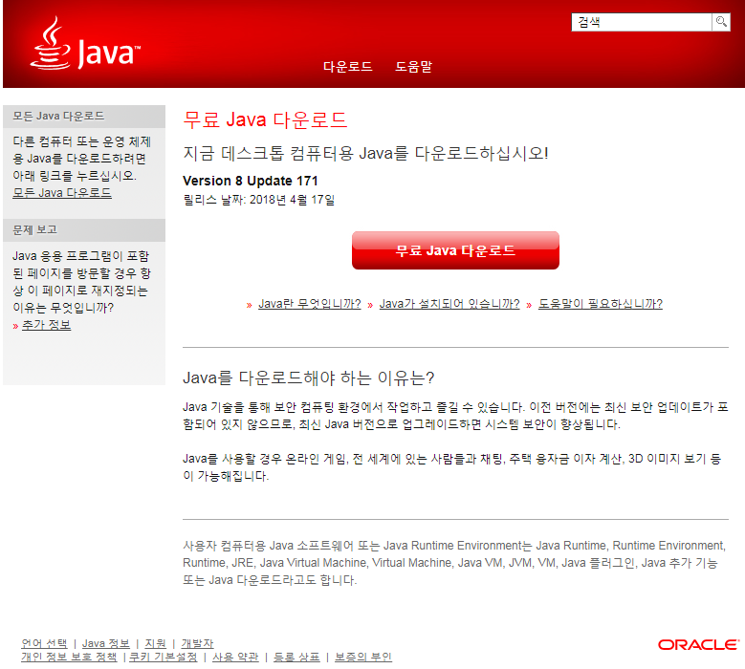
  2. Install the downloaded file.

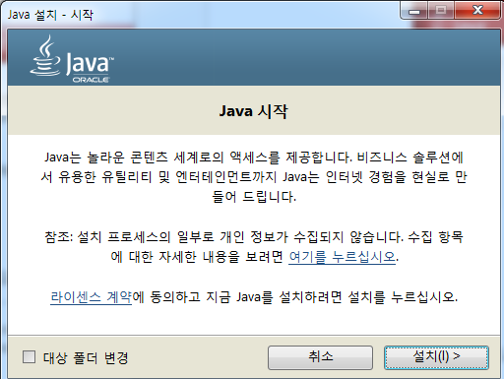 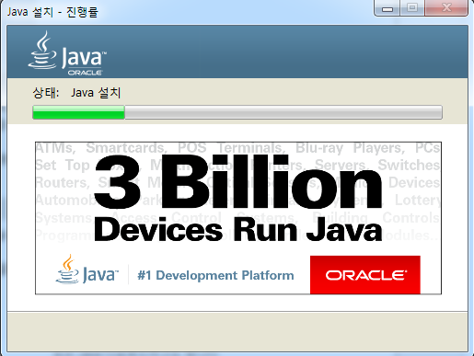

* 1. You are ready to run “Fatter” application.

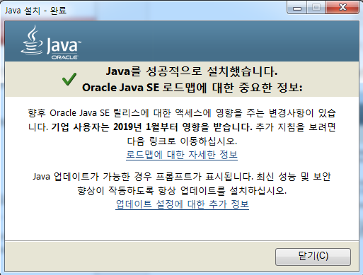

* Java JRE Download
  1. Click JRE Download from <http://www.oracle.com/technetwork/java/javase/downloads/index.html>.

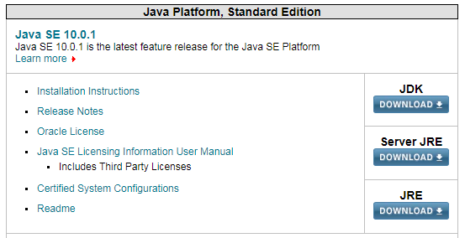

* 1. Select an install program according to the operation system.

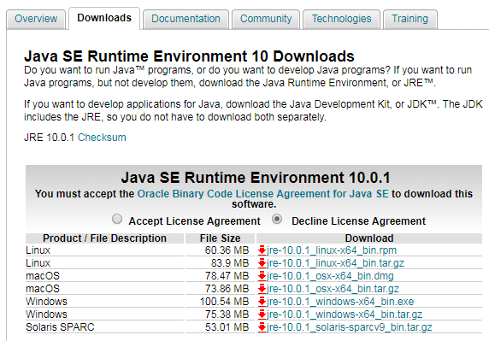

* 1. Install the downloaded file.

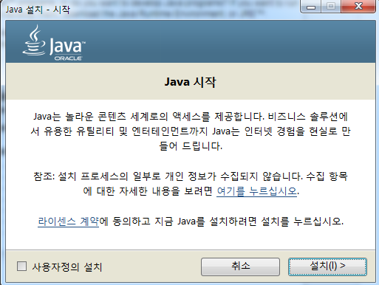 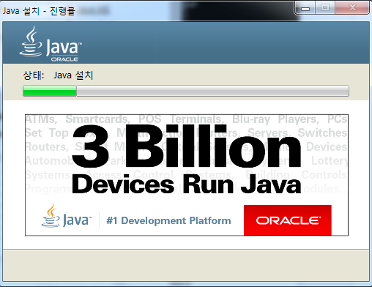

* 1. You are ready to run “Fatter” application.

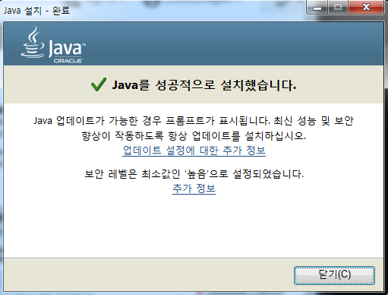

* Install 방법

github보여줘라??머죠

* + How to run the software
* Icon based method
  + - 1. Exe file should be located in the certain directory.

Therefore, the file must not be moved to other places.

* + - 1. Double click the program icon.



*.exe file is made by JSmooth*

* Command line based method
  1. Go to the system configuration.

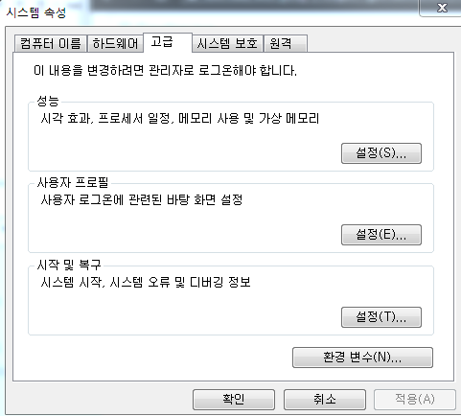

* 1. Insert java jre path into the computer system variable, *Path*.

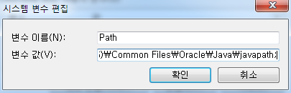

Ex) C:\Program Files (x86)\Common Files\Oracle\Java\javapath;

* 1. Type the running –jar command in cmd.



Command: java –jar *program_path*

* + A high-level description of the user view of your software

UI를 추가한 후 보여주기

* + How to use the software

UI를 통해 소개

* + How to report a bug
* Report a bug from the issue section in Github.

Github Address: <https://github.com/hyungjuneC/Fatter> (hyungjuneC / Fatter)

* 1. Click new issue button in the issue section.

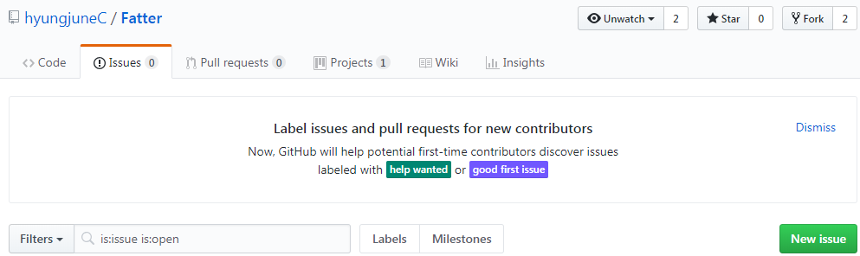

* 1. Write down the bug on the project.

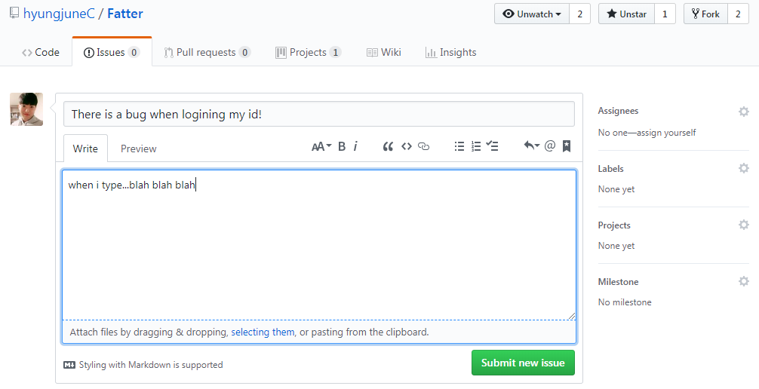

* 1. There will be a solution proposed by the developers or other users.

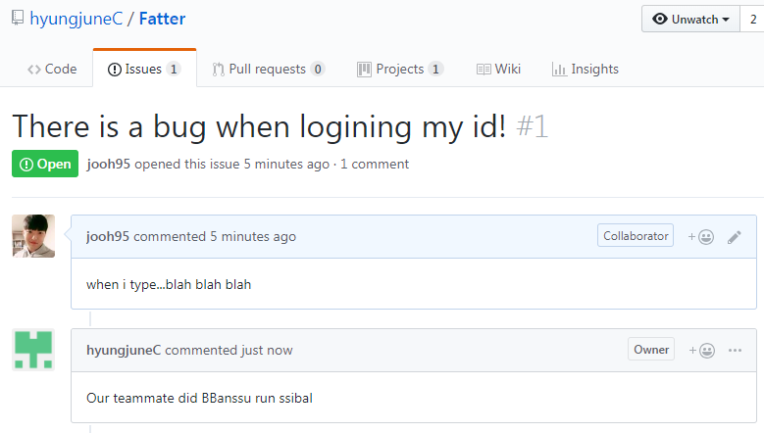

* Report a bug from email.

Email Address: <mailto:hyungjuneC@gmail.com>

1. **Documentation for developers**
   * How to obtain the source code

* Every single source code is uploaded to Github.

Github Address: <https://github.com/hyungjuneC/Fatter> (hyungjuneC / Fatter)

* 1. Go to “*Fatter*” Github website.

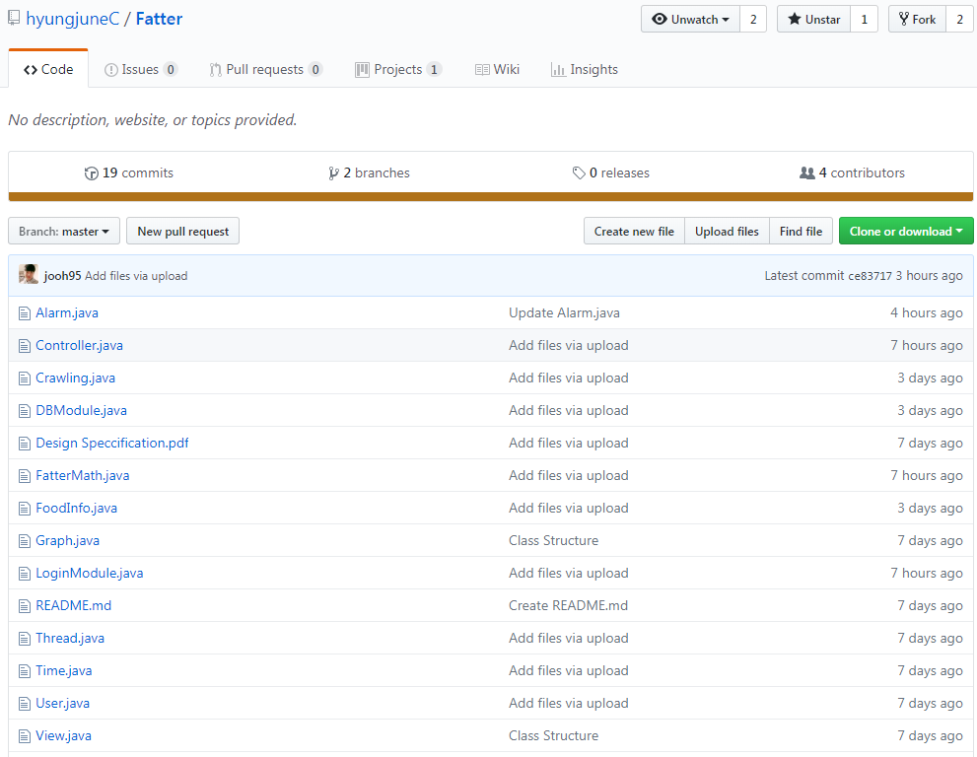

* 1. Click the green “Clone or download” button and download all source codes.

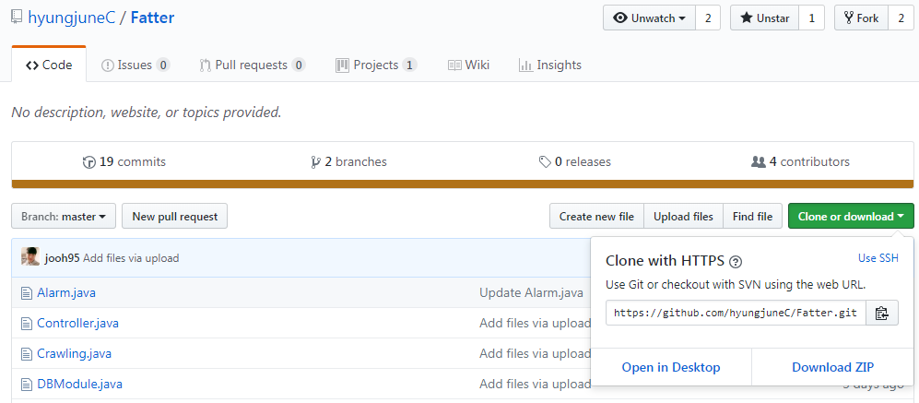

* + The layout of your directory structure

디렉토리 이미지로 표현

* + How to build the software
    - 1. Click *“Project”* in the eclipse tool bar.

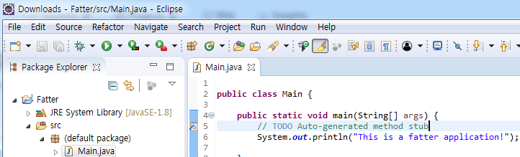

* + - 1. Click “build project” and the project is going to be built.

Ex) Project > Build project

* + How to test the software

|  |  |
| --- | --- |
| **Unit Test** | - Implement test cases for each methods in every class through **JUnit**.  Ex) junitì ëí ì´ë¯¸ì§ ê²ìê²°ê³¼ |
| **Class Test** | - Implement test cases in Main function of each class.  Ex) |

* + How to set up an automated daily (or more frequent) build and test
* Use automated build tool, ***Apache Ant***

Set **build.xml** for project name, directory path etc. Apache Ant will build the project automatically.

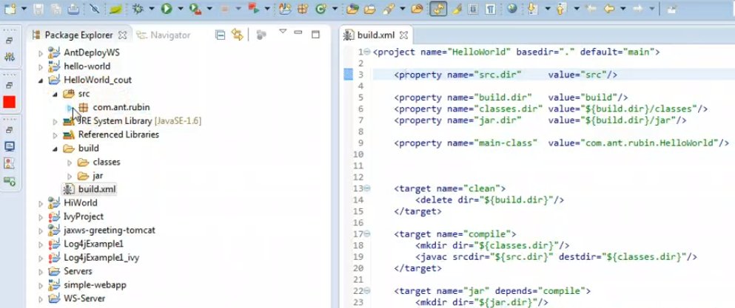

* + How to release a new version of your software

All changes, including new versions release, will be announced and distributed via our Github (<https://github.com/hyungjuneC/Fatter> [hyungjuneC / Fatter] ). We will use the branch in Github. Below image is an example of creating a new branch for the new version of source code.

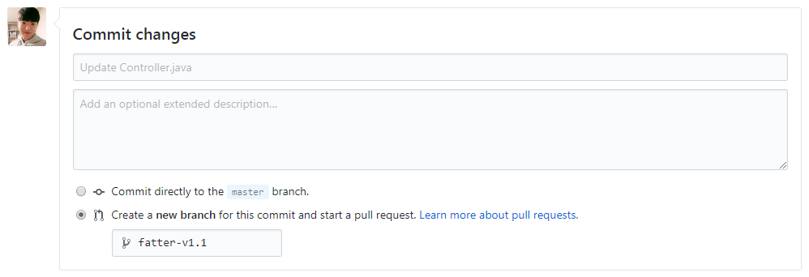

* + How to access the list of outstanding bugs and the list of resolved bugs, and how to resolve a bug